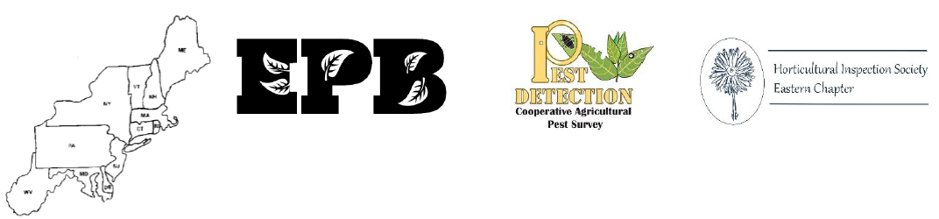

Please Join Us for the 98th Eastern Plant Board Meeting!
You are cordially invited to attend the 2024 Eastern Plant Board meeting, to be held April 1-4th in Burlington, Vermont. The Cooperative Agricultural Pest Survey and the Eastern Chapter of the Horticultural Inspection Society will once again be joining us in hosting concurrent meetings with their members.
Burlington VT is on the shore of the beautiful Lake Champlain and has many culinary and scenic areas of interest within walking distance of the hotel.

Meeting Registration
Early registration will begin on February 15th and is $450 per person if received by March 18th. Full registration after March 18th is $500. Please note that the group room rates have been extended to March 18th.
Single day registration is as follows:
- Tuesday, April 2th: $300
- Wednesday, April 3th: $340
- Thursday April 4th: $240
Attendees may bring a guest for the reception, banquet, and field trip, at an additional cost of $175 per guest.
Register by visiting: https://www.eventbrite.com/e/2024-eastern-plant-board-registration-811326989867

Meeting Agenda
The meeting agenda can be found by visiting: https://www.nationalplantboard.org/meetings1.html

Accommodations

A block of rooms is available at the Hilton Burlington Lake Champlain, from Monday night through Wednesday night, with check out on Thursday morning. The hotel is located at 60 Battery Street. The meeting will be held in the hotel from Tuesday through Thursday (April 2-4), with registration and a reception Monday night April 1.
The cost of the room is $125/night plus $13.75 tax. To reserve a room, go to https://www.hilton.com/en/attend-my-event/bttvthf-epbm24-4a2e6a1d-b3f5-48f2-901d-1887dc0a9bda/. Use the group code EPBM24. Or call the Central Reservations Office at 1-800-HILTONS (445-8667), and mention our group, Eastern Plant Board Meeting- April 2024, to get the special discounted rate. Please note that the $25 Daily Mandatory Fee has been waived and you will still have access to wifi and the exercise facilities.
Hotel Reservations should be made no later than March 11, 2024.

Getting to Burlington VT
Burlington International Airport in Burlington, VT is the closest major airport, and is approximately 4 miles from the hotel, which is located at 60 Battery St. There is a city bus route, see https://ridegmt.com/11-airport/ or Uber, Lyft and taxi service.

Parking and Amenities

Parking is $16/day at the Hilton Lake Champlain garage. Additional details about parking in Burlington can be found at https://parkburlington.com/downtown/. Please note that parking at the Lakeview and College St garages is $8/24 hours.

Speaker Presentation Requirements
Speakers are asked to provide a copy of your presentation prior to your assigned time. Each presentation should be provided to Judy Rosovsky (judy.rosovsky@vermont.gov) prior to your arrival. At the very latest, your presentation should be provided to the moderator assigned to your speaker room on the morning of your presentation. Should you require any equipment other than the laptop and projector assigned to each room, please notify Judy Rosovsky at least one week prior to the meeting.

Exhibits
Participants are invited to bring displays, posters, or distribution items to share with the group. Please notify
Judy Rosovsky (judy.rosovsky@vermont.gov) in advance.

Weather and Attire
April temperatures in Burlington typically range from the 30’s at night to the 50’s in the day. The hotel is on a big lake so you may want to plan for it to be windy as well.

Field Trip

There will be three tours for attendees to choose from:
- ECHO Center: https://www.echovermont.org/ Be sure to check out their invasive species exhibit
- Shelburne Farms: https://shelburnefarms.org/ Limited to 25 participants
- Self-guided natural history tour: Champlain Mill History exhibit, Salmon Hole Fish Elevator, Salmon Hole Natural Area and unique geological feature Lone Rock Point. More info will be sent by email.

Because there is limited space at Shelburne Farms, you will be asked to select your top choice during the registration process, and field trip slots will be assigned on a first come, first served basis.

Door Prizes
If you would like to donate a door prize representing your state or agency or a fun item to share, we will be collecting door prizes at the registration desk and will ask you to fill out a door prize form when you register.

Contact Information

For further information, contact Judy Rosovsky at (802) 279-2212 or by email at judy.rosovsky@vermont.gov.

